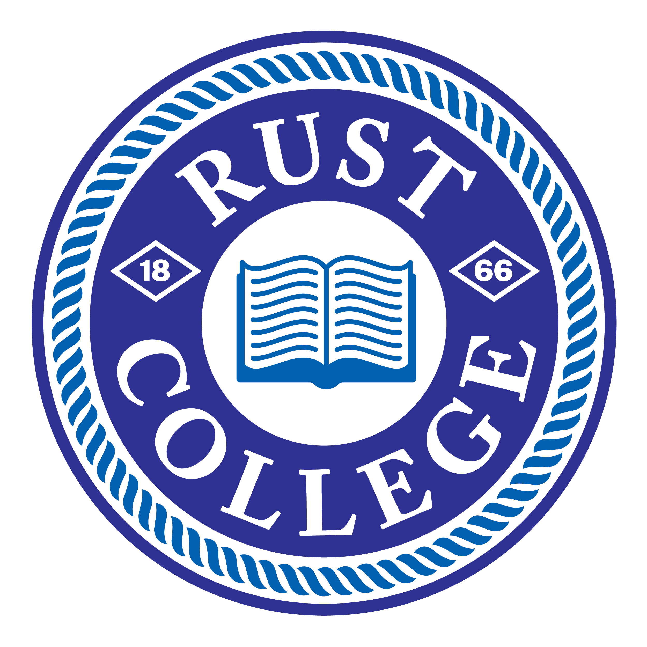
Dependency Status Form
2023-2024
Orphan or Ward of the Court/ Unaccompanied Minor/ Legal Guardianship or Emancipated Minor

Purpose- At the time you completed the 2023-2024 FAFSA, you indicated that you were an independent student. Before we can determine your financial aid eligibility, you need to confirm your status and attach the required documentation. If you do not meet the criteria for independent status, you will be required to update your FAFSA with parent information.

Your status must be verified before the processing of your federal financial aid application can be completed. Please complete this form and return it with all required documentation to the Financial Aid Office.
Student Information
Student Name3 |  |  | LincolnU Student ID | Date Of Birth
Home Address |  | LincolnU Email
City | State / Zip |  | Home Phone (+ Area Code) |  | Cell Phone (+ Area Code)
Independent Status Categories
Please indicate which status accurately reflects your situation by checking the appropriate box and return this form signed and completed to Rust College Financial Aid Office with the requested documentation attached.
I am or was an Orphan at any time from the age of 13 or older (check this box if both of your parents are deceased; do not check if only one parent is deceased or the whereabouts of your parent is unknown).
Attach a copy of each parent’s Death Certificates and/ or Obituaries.

I am or was a ward of the court at any time since the age of 13 (check this box even if you are no longer a dependent/ ward of the court as of today).
- Attach court documentation showing that you were removed from the home because it posed a direct threat to your well-being.

I am or was in Foster Care since the age of 13.
- Submit legal court documentation from your state of residency.

My high school or school district homeless liaison determined that I was an unaccompanied youth who was homeless on or after July 1, 2022
- Submit a letter (on letterhead) from the school official verifying this determination of your status.

The director of an emergency shelter or transitional housing program funded by the U. S. Department of Housing and Urban Development determined that I was an unaccompanied youth that was homeless on or after July 1, 2022.
- Submit a letter (on letterhead) from the director verifying this determination of your status.
The director of a runaway or homeless youth basic center or transitional living program determined that I was an unaccompanied youth who was homeless or was self-supporting and at risk of being homeless on or after July 1, 2022.
- Submit a letter (on letterhead) from the director verifying this determination of your status.
x | As of today, I am or was in legal guardianship as determined by a court in my state of legal residence.  - Submit a copy of the court’s decision that you were in legal guardianship before you reached the age of being an adult in your state. The court must be located in your state of legal residence at the time the court’s decision was issued.
x | As of today, I am an emancipated minor as determined by a court in my state of legal residence  - Submit a copy of the court’s decision that you were an emancipated minor before you reached the age of being an adult in your state. The court must be located in your state of legal residence at the time the court’s decision was issued.
I made an error on my FAFSA. I am not an orphan or ward/dependent of the court, nor was I ever in foster care.
YES, I have corrected the error on my 2023-2024 FAFSA and updated my application with my parent(s) information.
NO, I have not corrected the error on my 2023-2024 FAFSA. I understand that I must now correct my FAFSA and provide my parent(s) information
www.FAFSA.gov.
Certification Statement
I certify that the information provided on this form and all attached documentation is true and complete to the best of my knowledge. I agree to provide further documentation for verification of this information if requested by Rust College Financial Aid Office.
Student Signature & Date

